

Task 3 – Credit Submission

Student Name: Truong Ngoc Gia Hieu
Student Number (Vietnam/Australia): SWS01217/ 105565520

Task Credit3a
Firstly, the first task of the third laboratory in the Credit section requires students to write a query that meets the following requirements:
- For each row in the MOVIE table, display the stuid, Movieno, title, release year, ratingcode, runtime, the matching short description from the RATING table and the colour name from the COLOURTYPE table.
- Only display rows that have runtime of greater than 170 minutes .
- Only display rows that have a rating code of M or MA.
- The list must be in Ascending Movie no sequence.
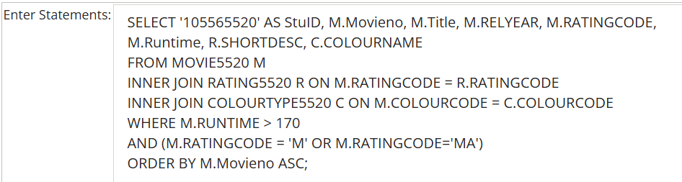
Figure 1: SQL Query Statement for Task Credit3a.
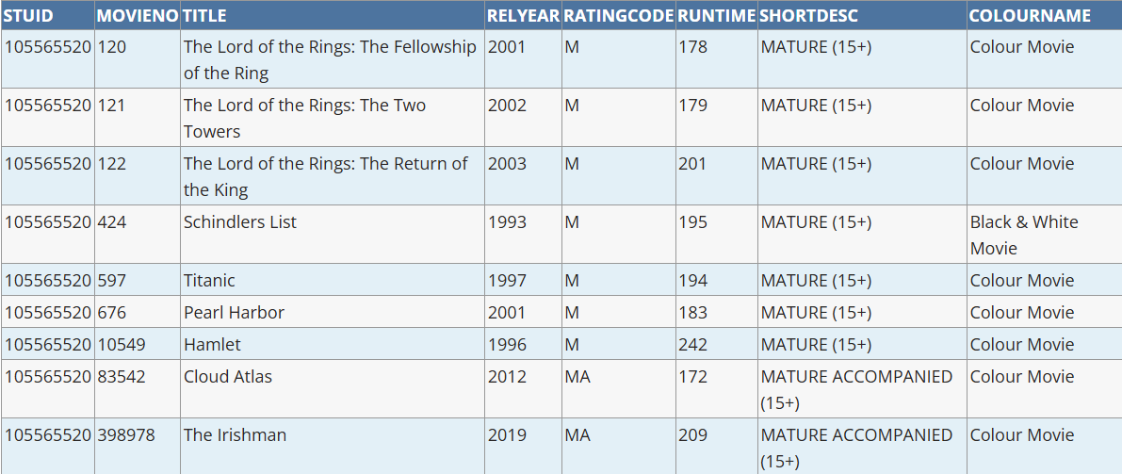
Figure 2: Output Result for Task Credit3a SQL Query.

Task Credit3b
Next, for the Credit 3b task, students are required to write a SQL statement that does the following:
- Display the StuId, MovieNo, Title, Runtime, Rating code, Rating Short Description, tmdb score for movies that meet any of these criteria:
- Rating code of MA plus a runtime between 100-105 (inclusive)
- Rating code of G plus a runtime less than 90
- Rating code of PG plus a runtime between 120-125 (inclusive)
- Rating code of M plus a runtime 170 minutes or more
- The query must only include movies that have a tmdb_score between 6.8 and 7.4 inclusive
- The list must be in Ascending Movie no sequence.
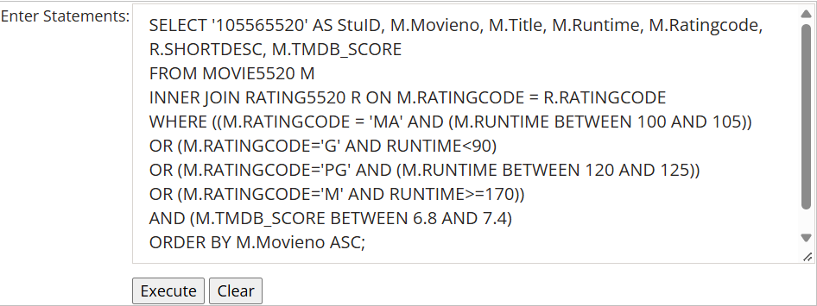
Figure 3: SQL Query Statement for Task Credit3b.
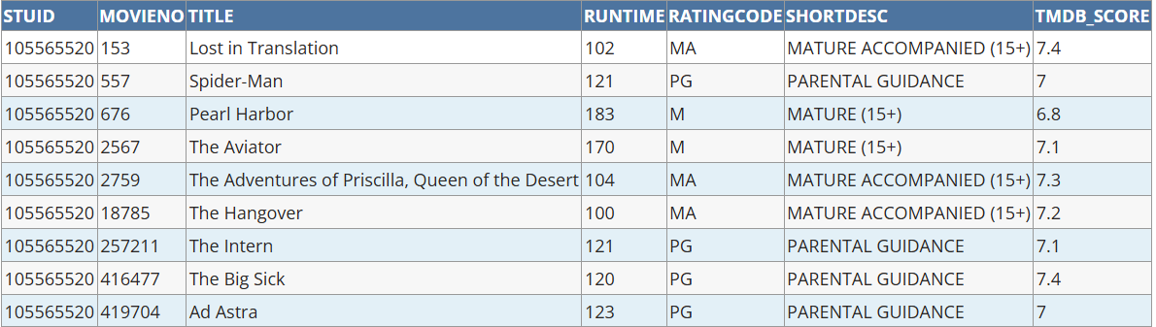
Figure 4: Output Result for Task Credit3b SQL Query.

Task Credit3c
Next, in the third task of the Credit section, the laboratory requires students to write a single SQL statement that displays all the release years in the movie table. Furthermore, the list must not repeat any value, and the resulting dataset must be sorted in descending order by release year.

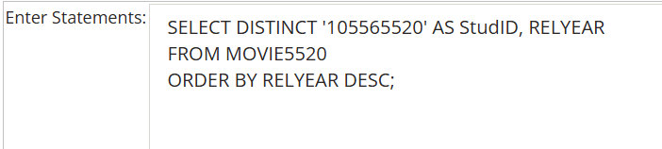
Figure 5: SQL Query Statement for Task Credit3c.
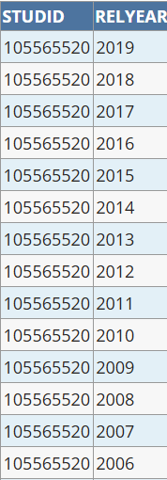

Figure 6: Output Result for Task Credit3c SQL Query.

Task Credit3d
In the fourth task of the Credit section, the laboratory requires updating specific movie records based on runtime and rating conditions, verifying the changes, and displaying the filtered datasets according to defined sorting criteria.
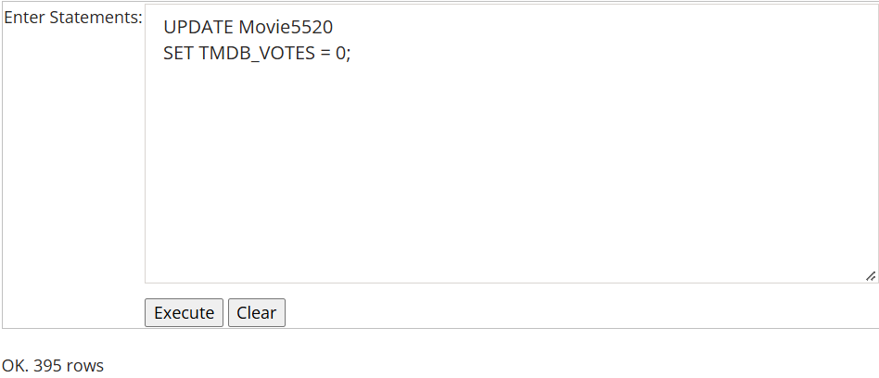
Figure 7: Update Statement to Set TMDB_VOTES to 0.
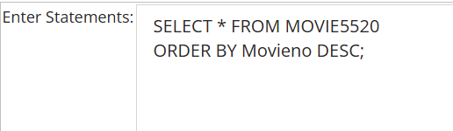
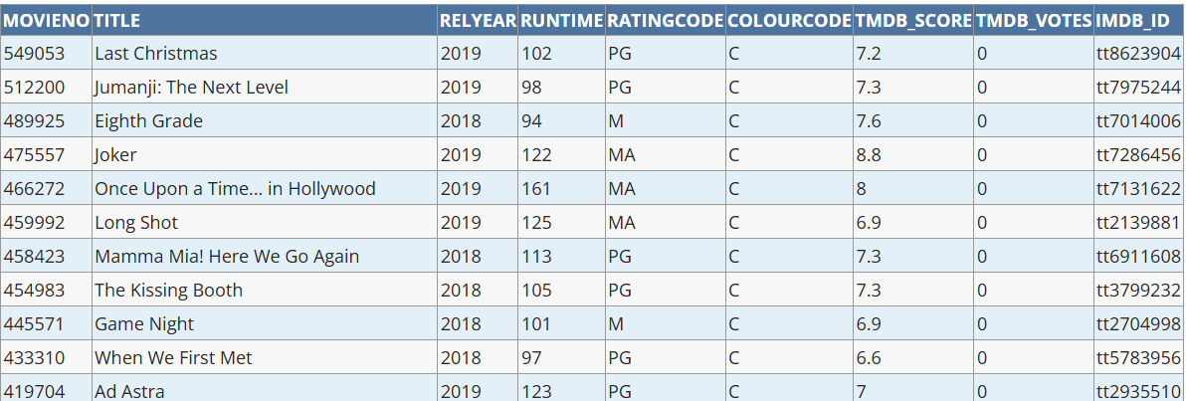
Figure 8: SQL Query Statement to Display Movies in Descending Movieno Sequence.
Figure 9: Output Result Showing TMDB_VOTES Set to 0.
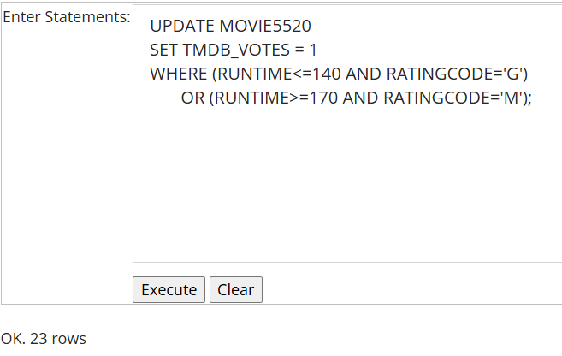
Figure 10: Update Statement to Set Conditional Values.
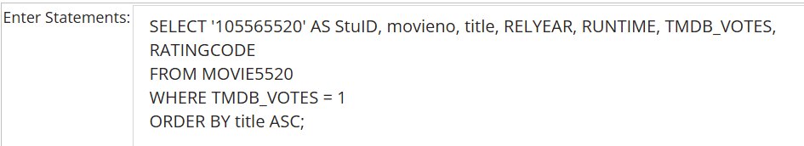
Figure 11: SQL Query Statement for Movies with TMDB_VOTES Equal to 1.
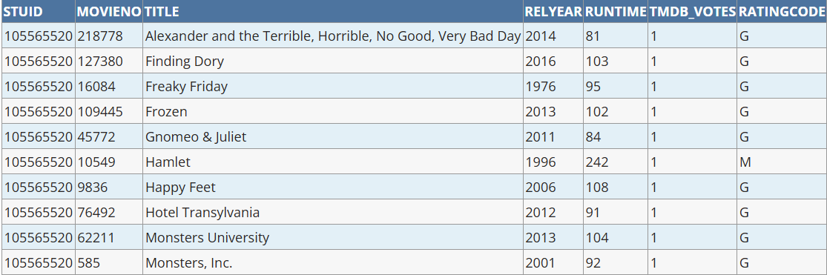
Figure 12: Output Result for Movies with TMDB_VOTES Equal to 1.

Task Credit3e
In the task Credit3e, the laboratory requires students to write an SQL statement that displays the student ID alongside all columns from the movie table. In addition, the query must filter the results to only include movies whose titles do not contain any of the letters A, B, I, or O, regardless of case. Finally, the resulting list must be sorted in descending order by the movie title.
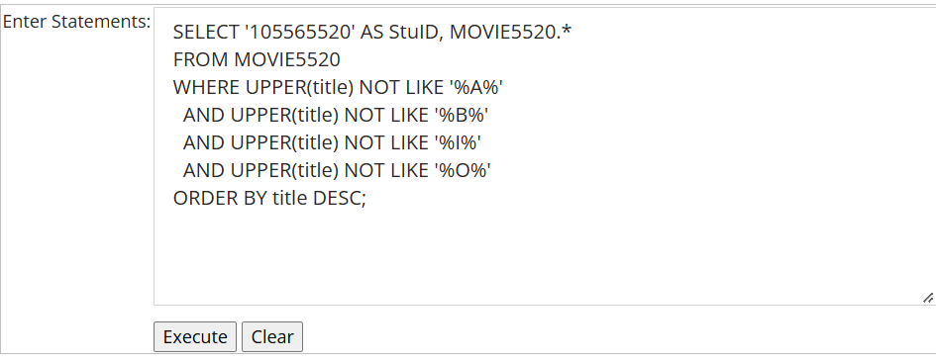
Figure 13: SQL Query Statement for Task Credit3e.
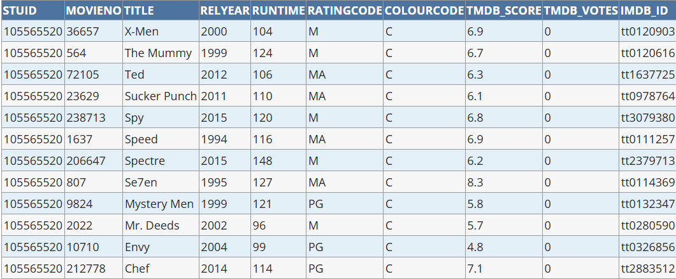
Figure 14: Output Result for Task Credit3e.

Task Credit3f
In this section, students have to create a table named CAR5520 based on the relational schema and the ERD below. Then, students have to save the SQL script into a file named create_car_sql.txt.
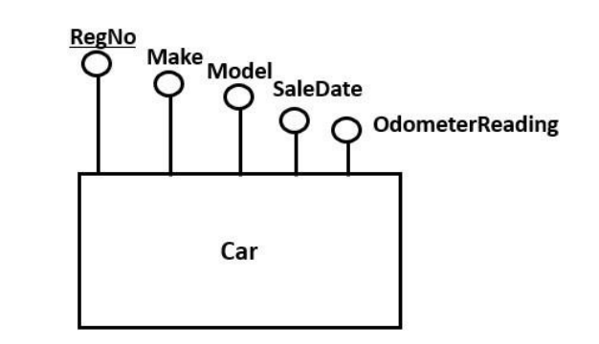
Figure 15: Entity-Relationship Diagram for Car Entity.
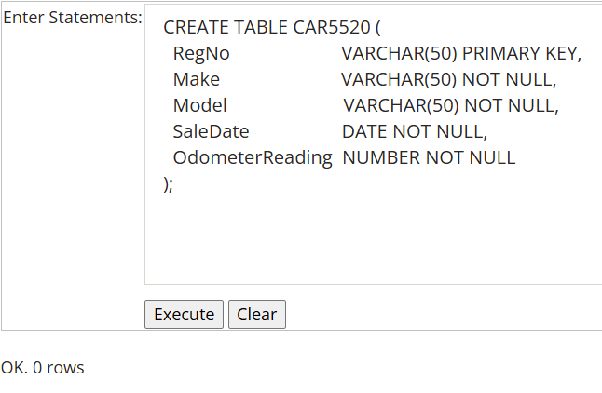
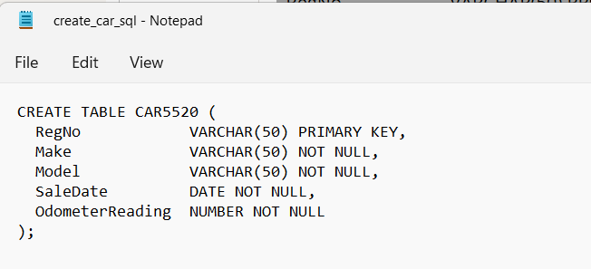
Figure 16: SQL Script to Create CAR5520 Table.
Figure 17: Execution Result for Creating CAR5520 Table.

Task Credit3g
In this section, students are required to write an SQL script containing at least four mock data rows for the CAR5520 table (including the mandatory sample record and user-defined records) and save the script into a file named Insert_car_sql.txt to populate the database.
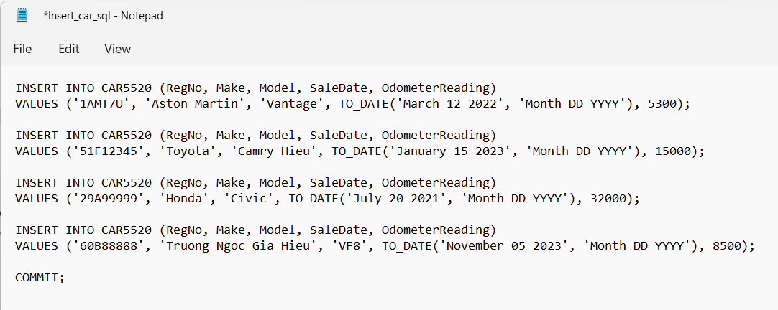
Figure 18: SQL Script to Insert Data into CAR5520 Table.
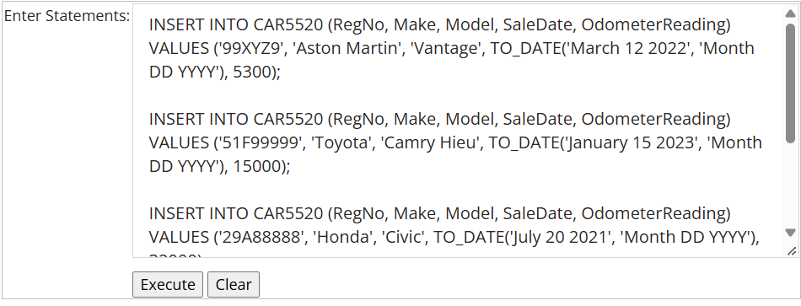
Figure 19: Execution Result for Inserting Data into CAR5520 Table.
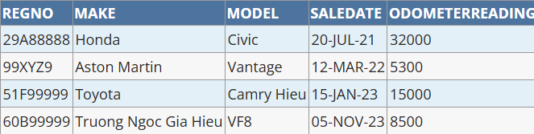
Notably, iSQLJunior does not allow multiple rows to be inserted in a single script execution, so each insert statement had to be run individually to populate the CAR5520 table successfully.
Figure 20: Data Content of CAR5520 Table.

Task Credit3h
In this section, students are required to write an SQL statement to list all rows of the CAR5520 table in ascending order of the primary key.
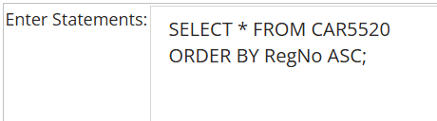
Figure 21: SQL Query Statement to Display All Records Sorted by Primary Key.
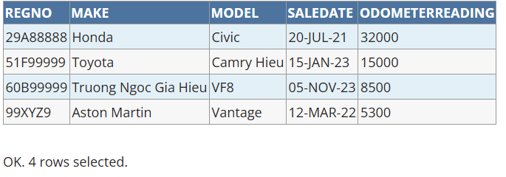
Figure 22: Output Result for CAR5520 Records Sorted by Primary Key.

Task Credit3i
Based on the requirement, students are required to write and execute an SQL statement to list all rows of the CAR5520 table for cars that have traveled less than a specified distance.
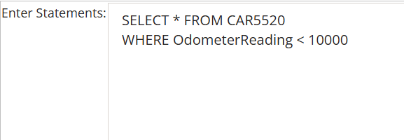
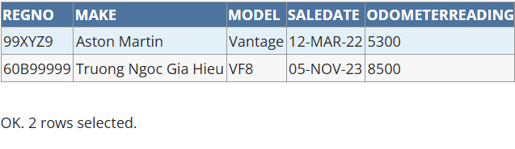
Figure 23: SQL Query Statement for Cars Traveled Less Than 10,000 Distance Units.
Figure 24: Output Result for Cars Traveled Less Than 10,000 Distance Units.

Task Credit3j
In the final task, students are required to write and execute an SQL statement to list all rows of the CAR5520 table for cars that have a sale date after a specified date (for example, after January 01, 2022).
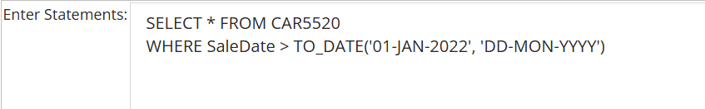
Figure 25: SQL Query Statement for Cars with Sale Date After January 01, 2022.
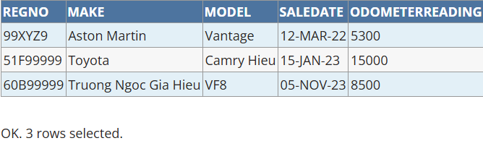
Figure 26: Output Result for Cars with Sale Date After January 01, 2022.

Conclusion
In conclusion, this laboratory successfully reinforced relational database management and SQL querying skills using Oracle iSQLJunior. Through practical tasks, students created, populated, and queried the CAR5520 table using primary key sorting, advanced filtering, pattern matching, and date-based conditions. Furthermore, all implemented statements and verification results demonstrate a strong understanding of database design principles and accurate SQL execution for academic reporting.

